ASSIGNMENT-12.1
NAME:-P.VARSHITHA
BATCH:-14
ENROLLMENTNUMBER:-2503A52398
Task Description #1 (Sorting – Merge Sort Implementation) • Task: Use AI to generate a Python program that implements the Merge Sort algorithm. • Instructions: o Prompt AI to create a function merge_sort(arr) that sorts a list in ascending order. o Ask AI to include time complexity and space complexity in the function docstring. o Verify the generated code with test cases.
PROMPT:- Write a Python program to implement the Merge Sort algorithm. Create a function called merge_sort(arr) that sorts a list in ascending order. Include a docstring explaining the best, average, and worst-case time complexity and space complexity. Test the program with a sample list and display the original and sorted arrays.
INPUT:-
def merge_sort(arr):
"""
Merge Sort Algorithm
Time Complexity: O(n log n)
Space Complexity: O(n)
"""
if len(arr) <= 1:
return arr
mid = len(arr) // 2
left = merge_sort(arr[:mid])
right = merge_sort(arr[mid:])
result = []
i = j = 0
while i < len(left) and j < len(right):
if left[i] < right[j]:
result.append(left[i])
i += 1
else:
result.append(right[j])
j += 1
result.extend(left[i:])
result.extend(right[j:])
return result
arr = [38, 27, 43, 3, 9, 82, 10]
print("Original Array:", arr)
print("Sorted Array:", merge_sort(arr))
OUTPUT:-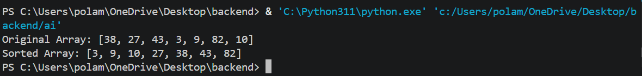
Task Description #2 (Searching – Binary Search with AI Optimization) • Task: Use AI to create a binary search function that finds a target element in a sorted list. • Instructions: o Prompt AI to create a function binary_search(arr, target) returning the index of the target or -1 if not Week6 Monday found. o Include docstrings explaining best, average, and worst-case complexities. o Test with various inputs.
PROMPT:- Write a Python program to implement Binary Search. Create a function binary_search(arr, target) that searches for an element in a sorted list and returns its index if found, otherwise returns -1. Include a docstring explaining best-case, average-case, worst-case time complexity and space complexity. Test the program with sample inputs.

INPUT:-
def binary_search(arr, target):
"""
Binary Search Algorithm
Best Case: O(1)
Average Case: O(log n)
Worst Case: O(log n)
Space Complexity: O(1)
"""
low = 0
high = len(arr) - 1
while low <= high:
mid = (low + high) // 2
if arr[mid] == target:
return mid
elif arr[mid] < target:
low = mid + 1
else:
high = mid – 1
return -1
arr = [10, 20, 30, 40, 50, 60, 70]
target = 40
result = binary_search(arr, target)
if result != -1:
print("Element found at index:", result)
else:
print("Element not found")
OUTPUT:-
Task Description #3 (Real-Time Application – Inventory Management System) • Scenario: A retail store’s inventory system contains thousands of products, each with attributes like product ID, name, price, and stock quantity. Store staff need to: 1. Quickly search for a product by ID or name. 2. Sort products by price or quantity for stock analysis. • Task: o Use AI to suggest the most efficient search and sort algorithms for this use case. o Implement the recommended algorithms in Python. o Justify the choice based on dataset size, update frequency, and performance requirements.
PROMPT:- Create a Python Inventory Management System for a retail store containing product ID, name, price, and quantity. Implement searching by product ID and product name using hashing. Implement sorting by price and quantity using efficient sorting algorithms. Display the search results and sorted products. Also explain the time complexity and justify the selected algorithms.
INPUT:-
products = [
{"id": 101, "name": "Laptop", "price": 50000, "quantity": 10},
{"id": 102, "name": "Mobile", "price": 20000, "quantity": 25},
{"id": 103, "name": "Tablet", "price": 30000, "quantity": 15},
{"id": 104, "name": "Keyboard", "price": 1000, "quantity": 50}
]
id_index = {p["id"]: p for p in products}
name_index = {p["name"].lower(): p for p in products}
def search_by_id(pid):
return id_index.get(pid, "Product not found")
def search_by_name(name):
return name_index.get(name.lower(), "Product not found")
def sort_by_price():
return sorted(products, key=lambda p: p["price"])
def sort_by_quantity():
return sorted(products, key=lambda p: p["quantity"])
print("Search by ID:", search_by_id(102))
print("Search by Name:", search_by_name("Laptop"))
print("\nProducts sorted by Price:")
for p in sort_by_price():
print(p)
print("\nProducts sorted by Quantity:")
for p in sort_by_quantity():
print(p)
OUTPUT:- 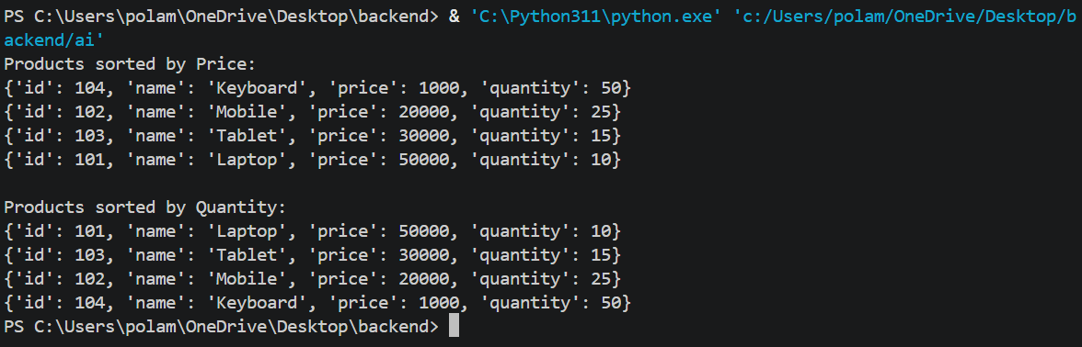
Task description #4: Smart Hospital Patient Management System A hospital maintains records of thousands of patients with details such as patient ID, name, severity level, admission date, and bill amount. Doctors and staff need to:1. Quickly search patient records using patient ID or name. 2. Sort patients based on severity level or bill amount for prioritization and billing.
PROMPT:- Write a Python program for a Smart Hospital Patient Management System. Store patient ID, name, severity level, and bill amount. Implement searching by patient ID and patient name using hashing. Sort patient records based on severity level and bill amount. Display the search results and sorted patient records. Explain the algorithm selection and time complexity.
INPUT:-
patients = [
{"id": 1, "name": "Ravi", "severity": 3, "bill": 5000},
{"id": 2, "name": "Kiran", "severity": 1, "bill": 15000},
{"id": 3, "name": "Arun", "severity": 2, "bill": 8000},
{"id": 4, "name": "Priya", "severity": 4, "bill": 3000}
]
id_index = {p["id"]: p for p in patients}
name_index = {p["name"].lower(): p for p in patients}
def search_by_id(pid):
return id_index.get(pid, "Patient not found")
def search_by_name(name):
return name_index.get(name.lower(), "Patient not found")
def sort_by_severity():
return sorted(patients, key=lambda p: p["severity"])
def sort_by_bill():
return sorted(patients, key=lambda p: p["bill"])
print("Search Patient:", search_by_id(2))
print("Search by Name:", search_by_name("Ravi"))
print("\nPatients by Severity:")
for p in sort_by_severity():
print(p)
print("\nPatients by Bill Amount:")
for p in sort_by_bill():
print(p)
OUTPUT:- 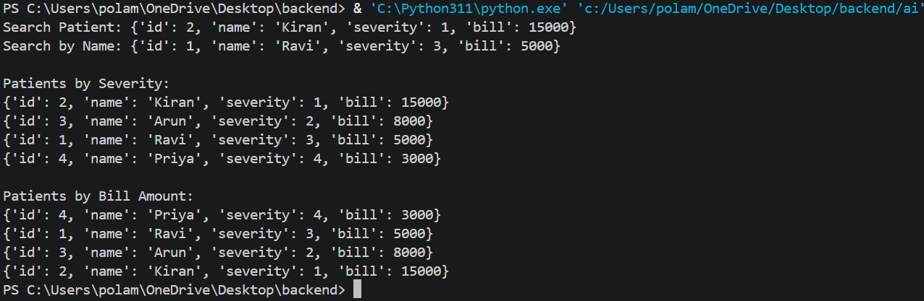
Task Description #5: University Examination Result Processing System A university processes examination results for thousands of students containing roll number, name, subject, and marks. The system must: 1. Search student results using roll number. 2. Sort students based on marks to generate rank lists.
PROMPT:- Create a Python program for a University Examination Result Processing System. Store student roll number, name, subject, and marks. Implement searching using roll number with hashing. Sort students based on marks in descending order to generate a rank list. Display the search result and student ranking. Explain the algorithm complexity and justify the selected algorithms.
INPUT:-
students = [
{"roll": 101, "name": "Ravi", "subject": "Maths", "marks": 85},
{"roll": 102, "name": "Kiran", "subject": "Maths", "marks": 92},
{"roll": 103, "name": "Arun", "subject": "Maths", "marks": 75},
{"roll": 104, "name": "Priya", "subject": "Maths", "marks": 95}
]
roll_index = {s["roll"]: s for s in students}
def search_student(roll):
return roll_index.get(roll, "Student not found")
def sort_by_marks():
return sorted(students, key=lambda s: s["marks"], reverse=True
print("Search Result:", search_student(102))
print("\nStudent Rank List:")
rank = 1
for s in sort_by_marks():
print(rank, s)
rank += 1
OUTPUT:- 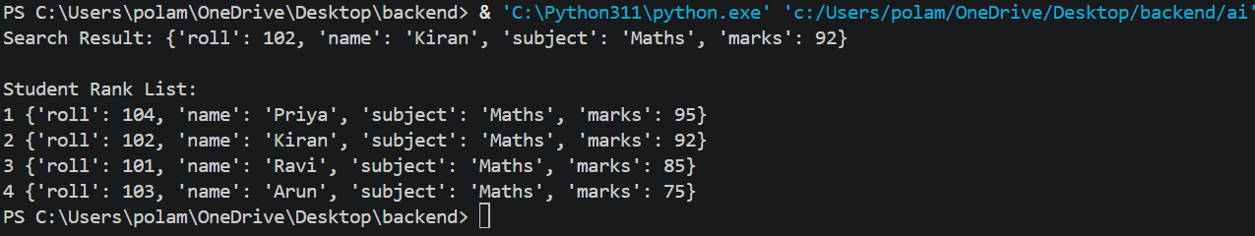

Task Description #6: Online Food Delivery Platform An online food delivery application stores thousands of orders with order ID, restaurant name, delivery time, price, and order status. The platform needs to: 1. Quickly find an order using order ID. 2. Sort orders based on delivery time or price.
PROMPT:-Write a Python program for an Online Food Delivery Platform. Store order ID, restaurant name, delivery time, price, and order status. Implement searching for an order using order ID with hashing. Sort orders based on delivery time and price using efficient sorting algorithms. Display the search result and sorted order details. Explain the time complexity and justify the selected algorithms.

INPUT:-
orders = [
{"id": 201, "restaurant": "ABC", "time": 30, "price": 250, "status": "Pending"},
{"id": 202, "restaurant": "XYZ", "time": 20, "price": 150, "status": "Delivered"},
{"id": 203, "restaurant": "PQR", "time": 45, "price": 300, "status": "Pending"},
{"id": 204, "restaurant": "LMN", "time": 15, "price": 100, "status": "Delivered"}
]
order_index = {o["id"]: o for o in orders}
def search_order(order_id):
return order_index.get(order_id, "Order not found")
def sort_by_time():
return sorted(orders, key=lambda o: o["time"])
def sort_by_price():
return sorted(orders, key=lambda o: o["price"])
print("Search Order:", search_order(202))
print("\nOrders sorted by Delivery Time:")
for o in sort_by_time():
print(o)
print("\nOrders sorted by Price:")
for o in sort_by_price():
print(o)
OUTPUT:- 

